GHARDA INSTITUTE OF TECHNOLOGY
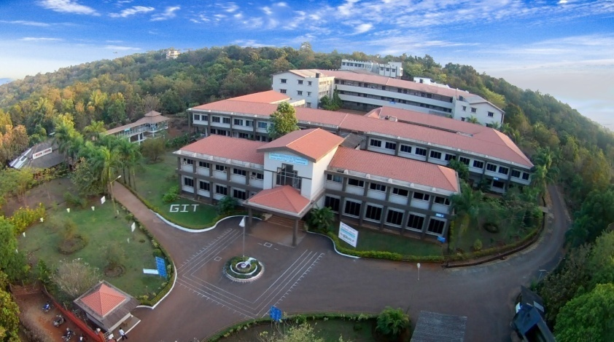
NAAC

Criteria VII

7.1.2 The Institution has facilities for alternate sources of energy and energy conservation measures

7.1.2 The Institution has facilities for alternate sources of energy and energy conservation measures
Sr No | Details | Link
1 | Alternate Sources of Energy and Energy Conservation Measures (Webpage) | Link : http://www.git-india.edu.in/git/about_ivbp_aseecm.html
2 | View Images Slideshow | Link : http://www.git-india.edu.in/git/naac/7.1.2/photogallery.asp
3 | Sensor based Energy Conservation : Report Washroom Automation | Link : http://www.git-india.edu.in/git/naac/7.1.2/Report%20washroom%20automation.pdf
4 | Geotagged Photographs PDF | Link : http://www.git-india.edu.in/git/naac/7.1.2/7.1.2%20Geotagged%20Photos.pdf

